

**K. J. Somaiya College of Engineering, Mumbai-77** (Somaiya Vidyavihar University)

**Name: Chandana Ramesh Galgali**

**Batch: P3-3 Roll No.: 16010422234**

**Experiment / ~~assignment~~ / ~~tutorial~~ No. 3**

**Grade: AA / AB / BB / BC / CC / CD /DD**

**Signature of the Staff In-charge with date**

| **TITLE:** Menu driven program. |
| --- |

**AIM:** Write a menu driven program for the following options:

a. To find whether a number is palindrome or not. (e.g. 1221 is palindrome)

b. To calculate the sum of the Fibonacci series up to ‘n’ terms. (use while loop only)

c. To find the numbers and the sum of all integers between 100 and 200 which are divisible by both 3 & 5. (use for loop only)

______**______________________________________________________________**

**Expected OUTCOME of Experiment:**

The program asks the user to choose from 4 options, the first three being palindrome, fibonacci and sum of common multiples of 3 and 5 between 100 to 200 respectively. The fourth option is to exit the program and if the user inputs an option number apart from 1 to 4, a default message is to be displayed as the output.

**_________________________________________________________________ Books/ Journals/ Websites referred:**

1. Programming in C, second edition, Pradeep Dey and Manas Ghosh, Oxford University Press.

2. Programming in ANSI C, fifth edition, E Balagurusamy, Tata McGraw Hill.

3. Introduction to programming and problem solving , G. Michael Schneider ,Wiley India edition.

4. **http://cse.iitkgp.ac.in/~rkumar/pds-vlab/**

**____________________________________________________________________**

**Department of Science and Humanities**

Page No PIC Sem I/August-December 2022-23



**K. J. Somaiya College of Engineering, Mumbai-77** (Somaiya Vidyavihar University)

**Problem Definition:**

The program accepts a choice from the user using a switch case statement and generates output accordingly.

**Choice a**: The program checks whether a given number by the user is a palindrome or not. If a number remains the same, even after reversing its digits then the number is known as a palindrome number.For example, 12321 is a palindrome number because it remains the same even if we reverse its digits.

**Choice b:** Sum of Fibonacci series up to n terms will be generated. Fibonacci series is a series in which each number is the sum of the last two preceding numbers. The first two terms of a Fibonacci series are 0 and 1. (use while loop only)

*Example:*

Input: n = 5

Output: 7

Explanation: 0 + 1 + 1 + 2 + 3 = 7

**Choice c:** To find the numbers and the sum of all numbers between 100 and 200 which are divisible by both 3 & 5. (use for loop only)

**Algorithm:** For the menu-driven program:



**Department of Science and Humanities**

Page No PIC Sem I/August-December 2022-23

For case(1):



For case(2):



For case(3):





**K. J. Somaiya College of Engineering, Mumbai-77** (Somaiya Vidyavihar University)

**Implementation details:**

#include<stdio.h>

#include<conio.h>

void main()

{

int option;

printf("1.The number is a Palindrome or not\n2.Sum of Fibonacci series upto 'n' terms\n3.Numbers between 100 and 200 divisible by 3 & 5 and their sum\n4.Exit");

printf("\nEnter the option number of the function to be performed: ");

scanf("%d",&option);

switch (option)

{

case 1:

{

int n,reverse_n=0,r,t;

printf("\nEnter the number: ");

scanf("%d",&n);

t=n;

do

{

r=t%10;

reverse_n=reverse_n*10+r;

t=t/10;

}

while(t!=0);

{

if(reverse_n==n)

{

printf("%d\nThe number is a palindrome.",n);

}

else

{

printf("%d\nThe number is not a palindrome.",n);

}

}

}

break;

case 2:

{

int a=0,b=1,c,n,sum=0,i=0;

printf("\nEnter the no. of terms in the Fibonacci series: ");

scanf("%d",&n);

printf("\nThe Fibonacci series is: ");

while(i<n)

{

printf("%d ",a);

sum=sum+a;

c=a+b;

a=b;

b=c;

i++;

}

printf("\nThe sum of Fibonacci series is: %d",sum);

}

break;

case 3:

{

int i,sum=0;

printf("\nNumbers between 100 and 200 divisible by 3 and 5: ");

for(i=101;i<200;i++)

{

if(i%3==0 && i%5==0)

{

printf("%d ",i);

sum=sum+i;

}

}

printf("\nThe sum of the numbers between 100 and 200 that are divisible by 3 and 5: %d",sum);

}

break;

case 4:

break;

default:

{

printf("\nEnter the option number from 1 to 4 only!");

}

break;

}

}

**Department of Science and Humanities**

Page No PIC Sem I/August-December 2022-23



**K. J. Somaiya College of Engineering, Mumbai-77** (Somaiya Vidyavihar University)

**Output(s):**

For option (1):

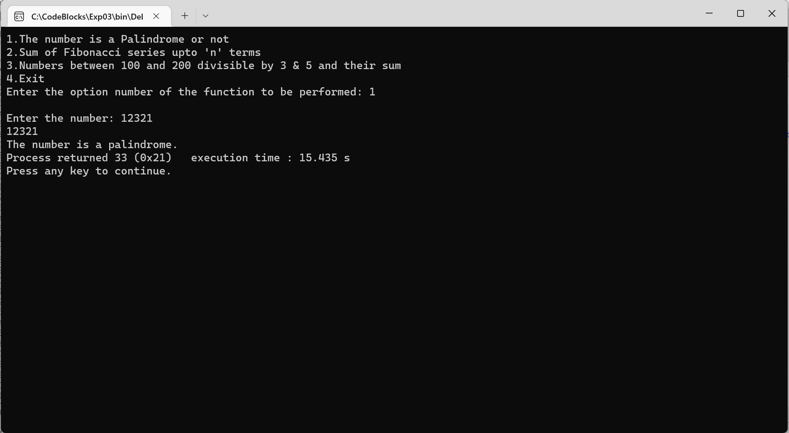

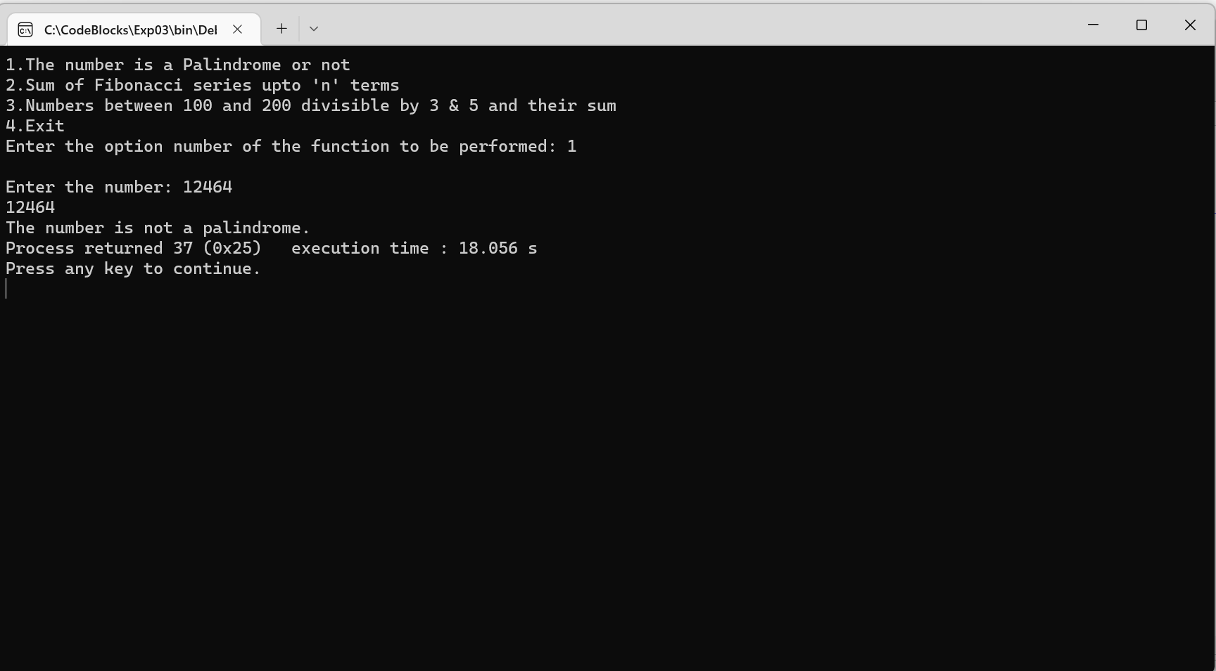

For option (2):

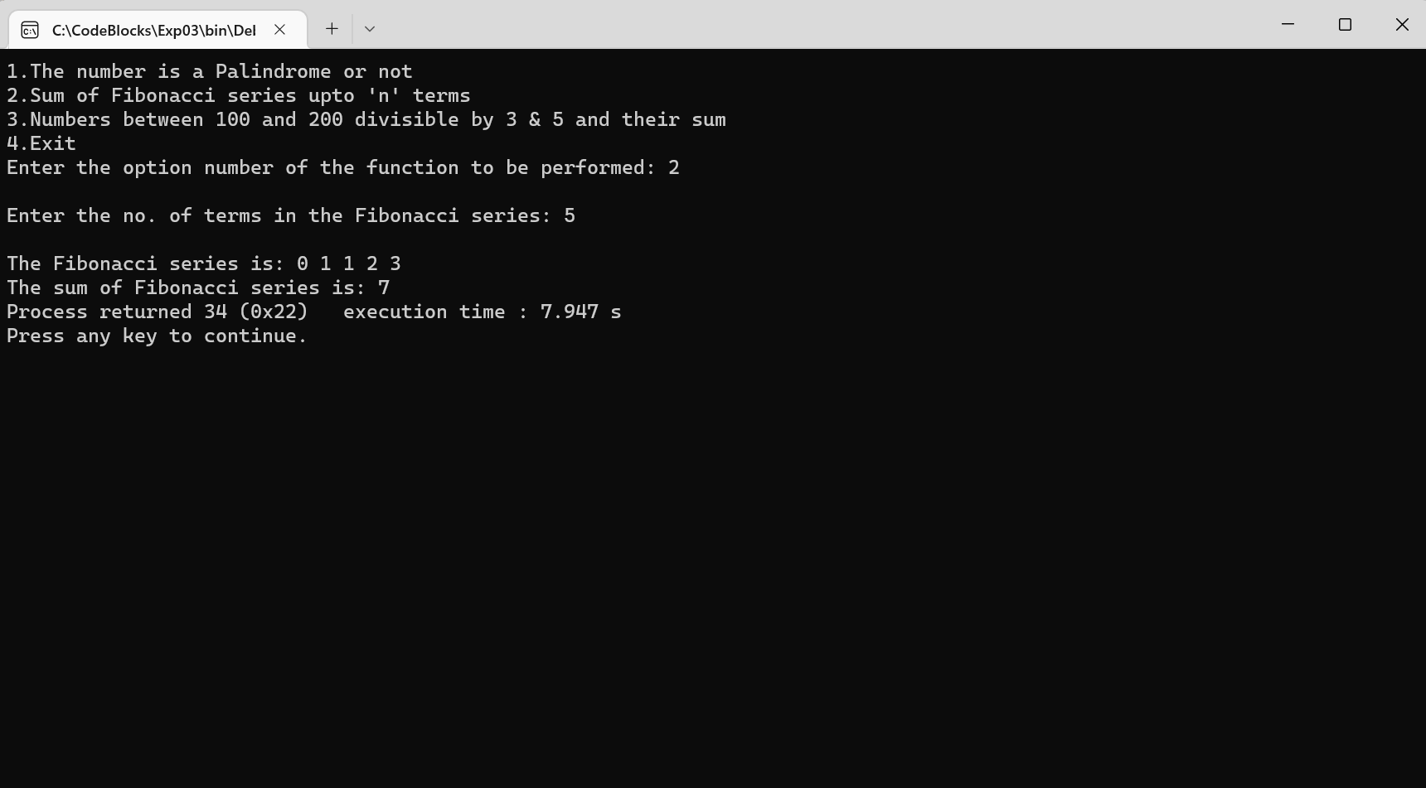

For option (3):

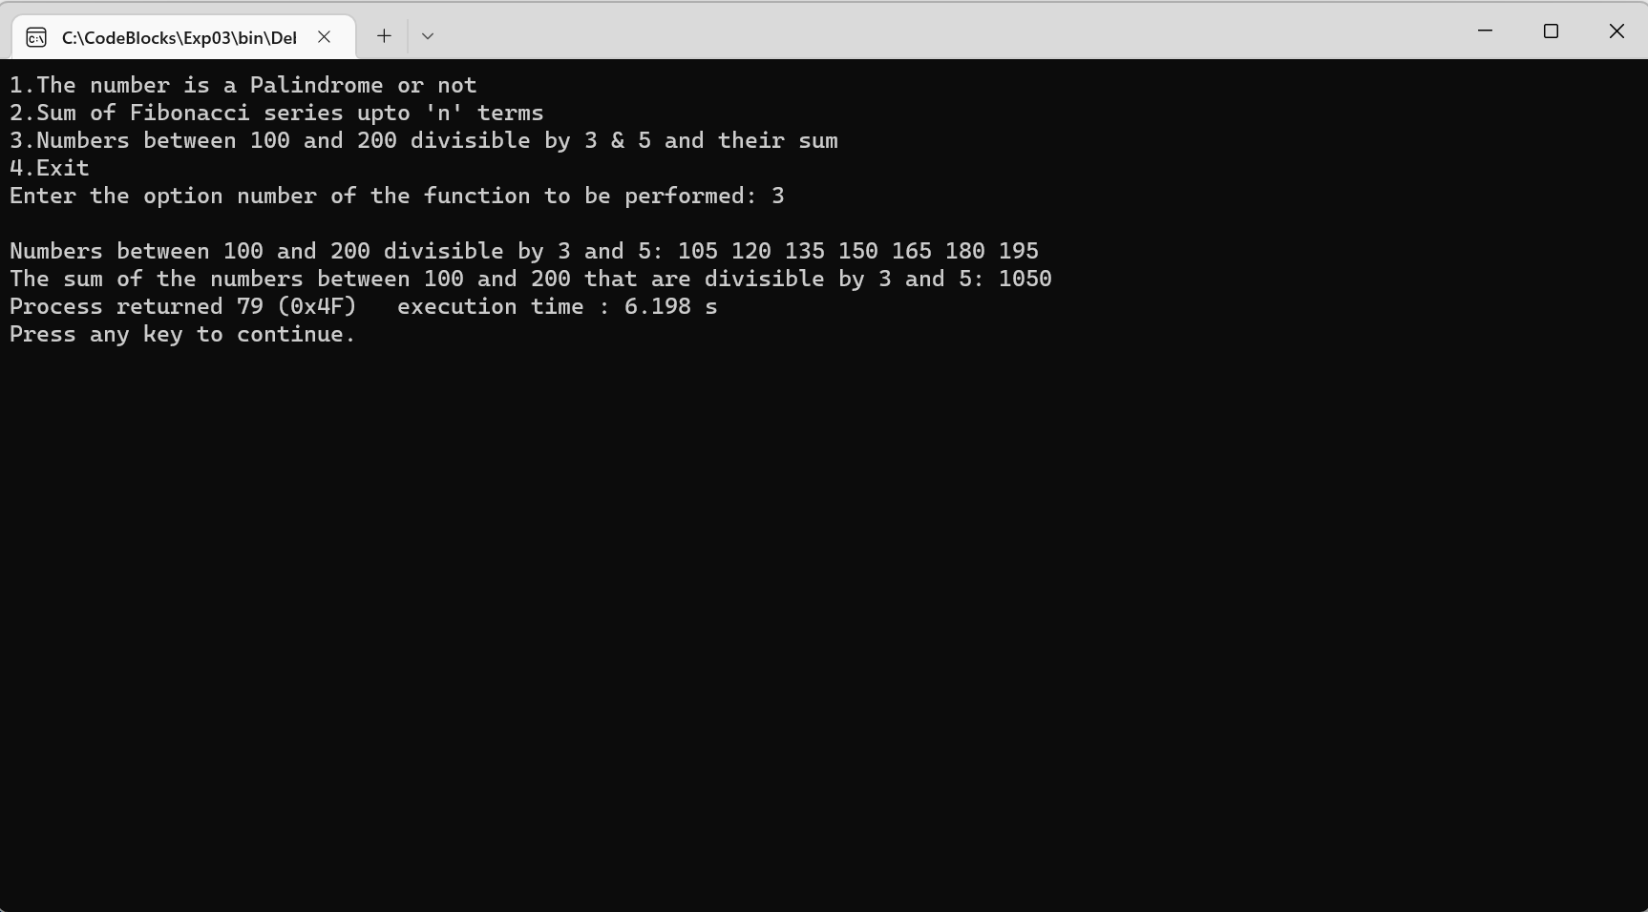

For option (4):

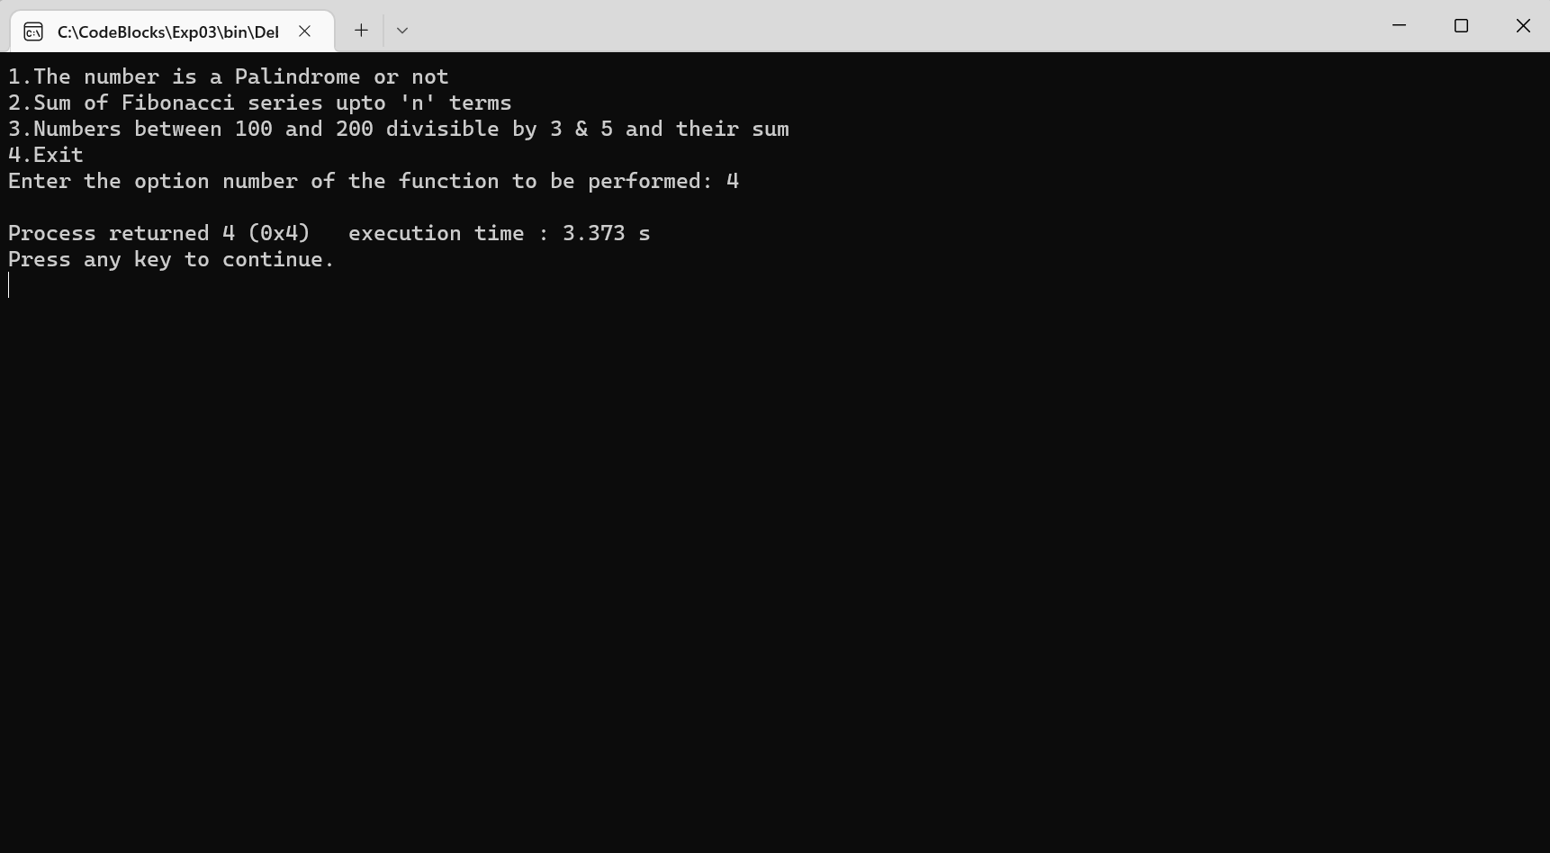

For any option other than 1-4:

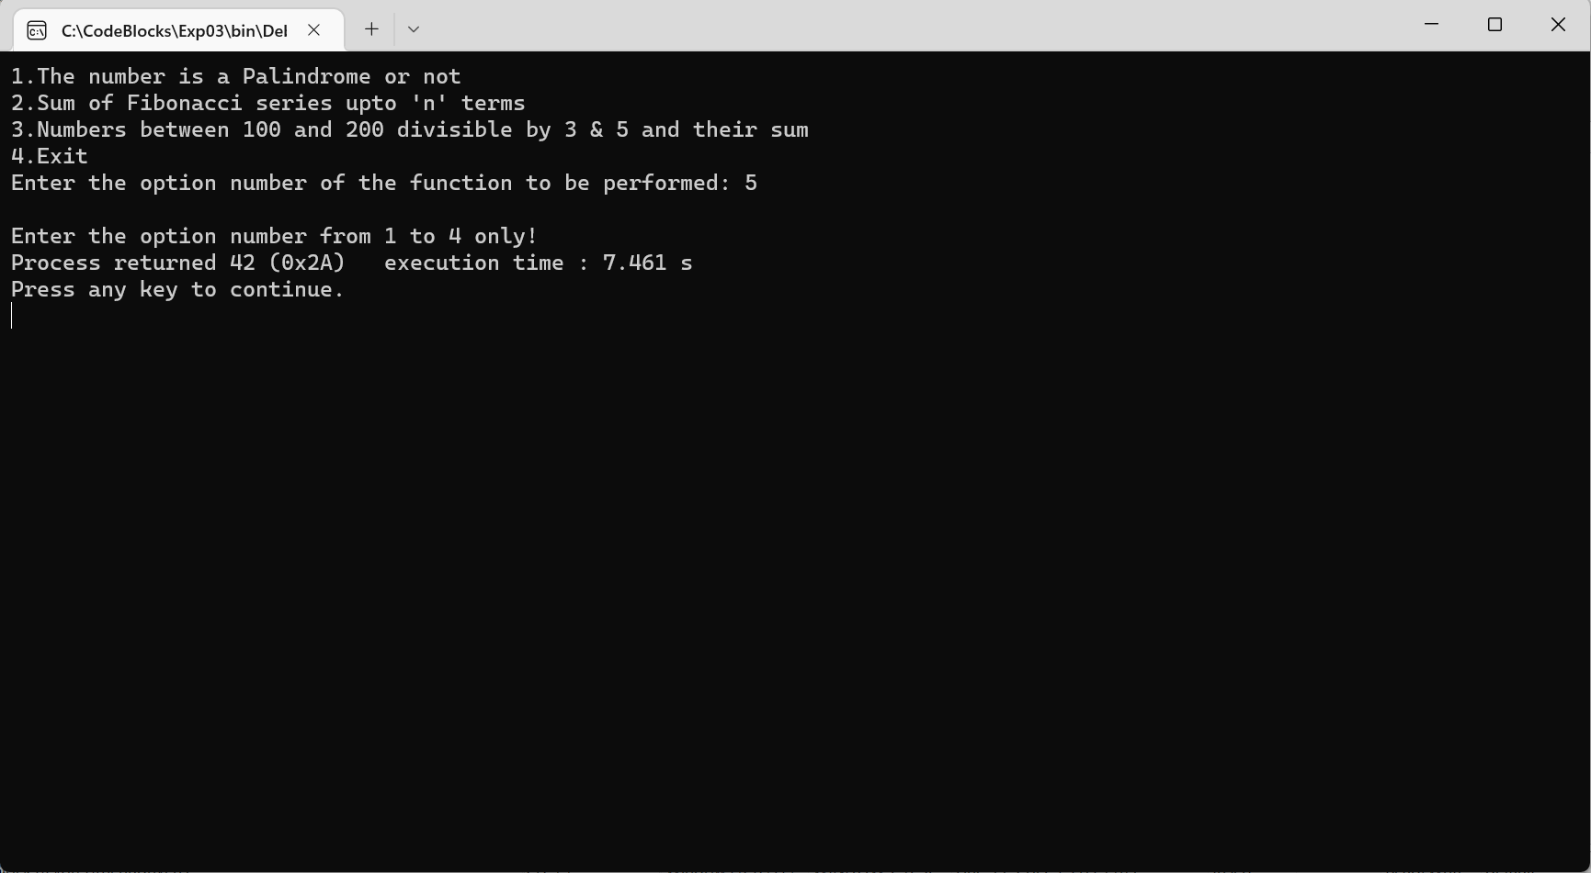

**Conclusion:**

The program accepts a choice from the user using a switch case statement and generates the output accordingly. If the user chose the first option, the number inputted by the user was checked to be a palindrome or not. On choosing the second option, the number of terms in the fibonacci series was taken as input and the series along with its sum was displayed as the output. When the user chose the third option, the numbers and the sum of all the numbers between 100 and 200 which are divisible by both 3 & 5 was outputted. The program exited when the fourth option was chosen. If an option apart from 1 to 4 was chosen, the default statement would be printed on the output screen.

**Post Lab Descriptive Questions**

**Write a menu driven code for the following:**

The program allows a user to enter five numbers and then asks the user to select a choice from a menu. The menu should offer the following options –

1. Display the smallest number entered.

2. Display the largest number entered.

3. Display the sum of the five numbers entered.

4. Display the average of the five numbers entered.

5. Exit.

Code:

#include<stdio.h>

#include<conio.h>

void main()

{

int a,b,c,d,e,option;

printf("Enter the five numbers: ");

scanf("%d%d%d%d%d",&a,&b,&c,&d,&e);

printf("1.Display the smallest number entered\n2.Display the largest number entered\n3.Display the sum of the five numbers entered\n4.Display the average of the five numbers entered\n5.Exit");

printf("\nEnter the option number: ");

scanf("%d",&option);

switch (option)

{

case 1:

{

if(a<b&&a<c&&a<d&&a<e)

{

printf("The smallest number entered is: %d",a);

}

else if(b<a&&b<c&&b<d&&b<e)

{

printf("The smallest number entered is: %d",b);

}

else if(c<a&&c<b&&c<d&&c<e)

{

printf("The smallest number entered is: %d",c);

}

else if(d<a&&d<b&&d<c&&d<e)

{

printf("The smallest number entered is: %d",d);

}

else

{

printf("The smallest number entered is: %d",e);

}

}

break;

case 2:

{

if(a>b&&a>c&&a>d&&a>e)

{

printf("The largest number entered is: %d",a);

}

else if(b>a&&b>c&&b>d&&b>e)

{

printf("The largest number entered is: %d",b);

}

else if(c>a&&c>b&&c>d&&c>e)

{

printf("The largest number entered is: %d",c);

}

else if(d>a&&d>b&&d>c&&d>e)

{

printf("The largest number entered is: %d",d);

}

else

{

printf("The largest number entered is: %d",e);

}

}

break;

case 3:

{

printf("\nThe sum of the five numbers is: %d",a+b+c+d+e);

}

break;

case 4:

{

printf("\nThe average of the five numbers is: %d",(a+b+c+d+e)/5);

}

break;

case 5:

break;

default:

{

printf("\nEnter the option number from 1 to 5 only!");

}

break;

}

}

For option (1):

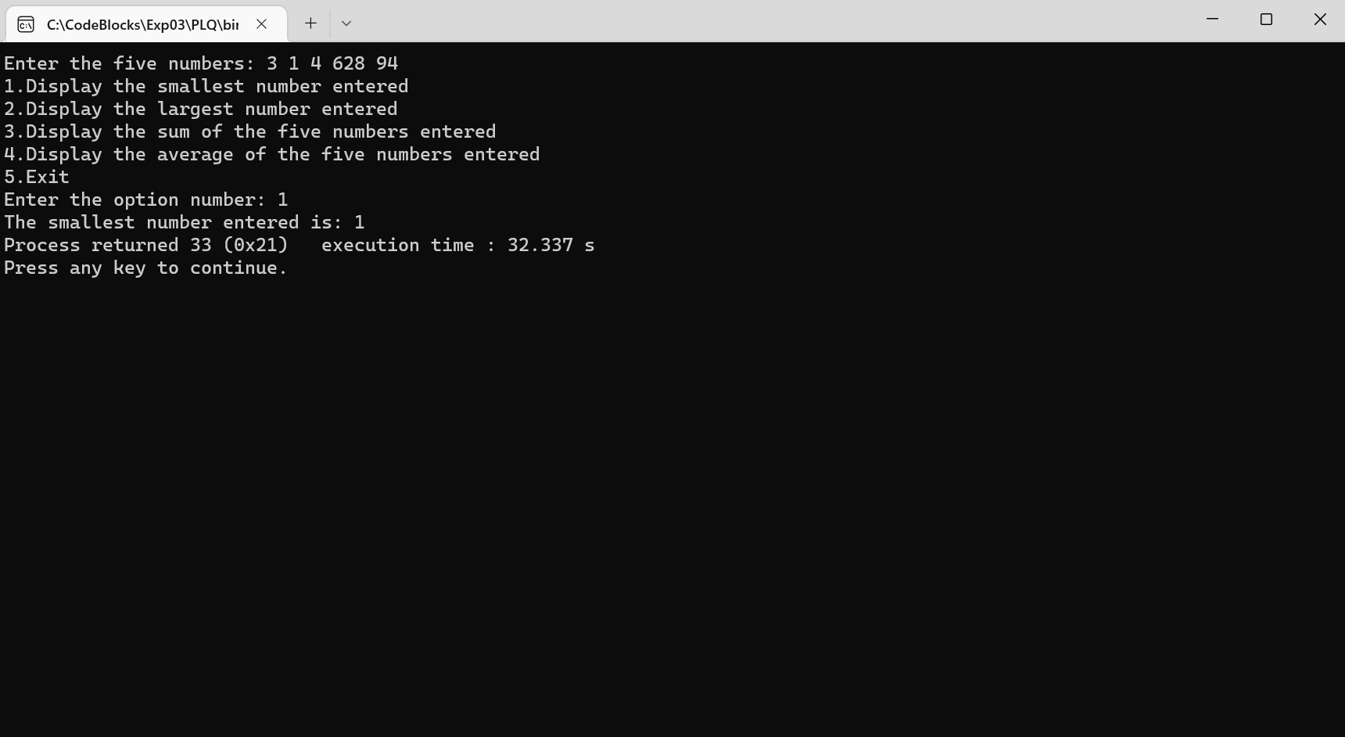

For option (2):

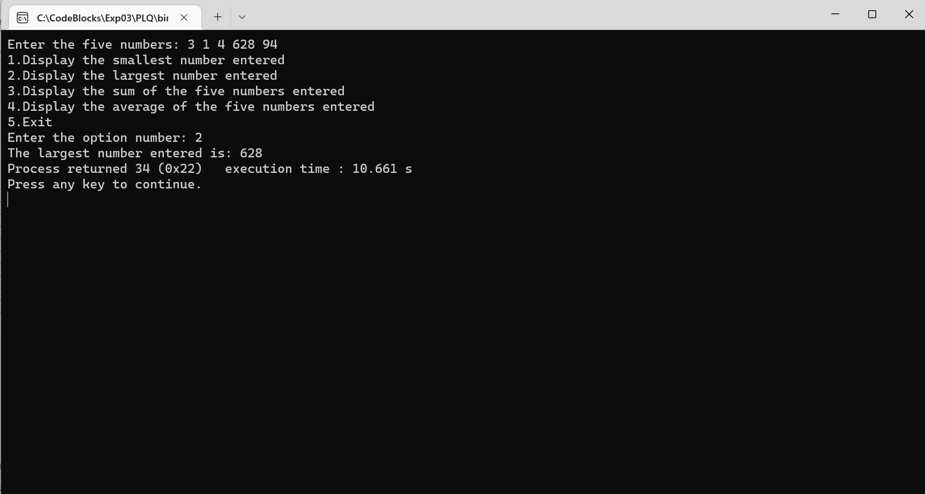

For option (3):

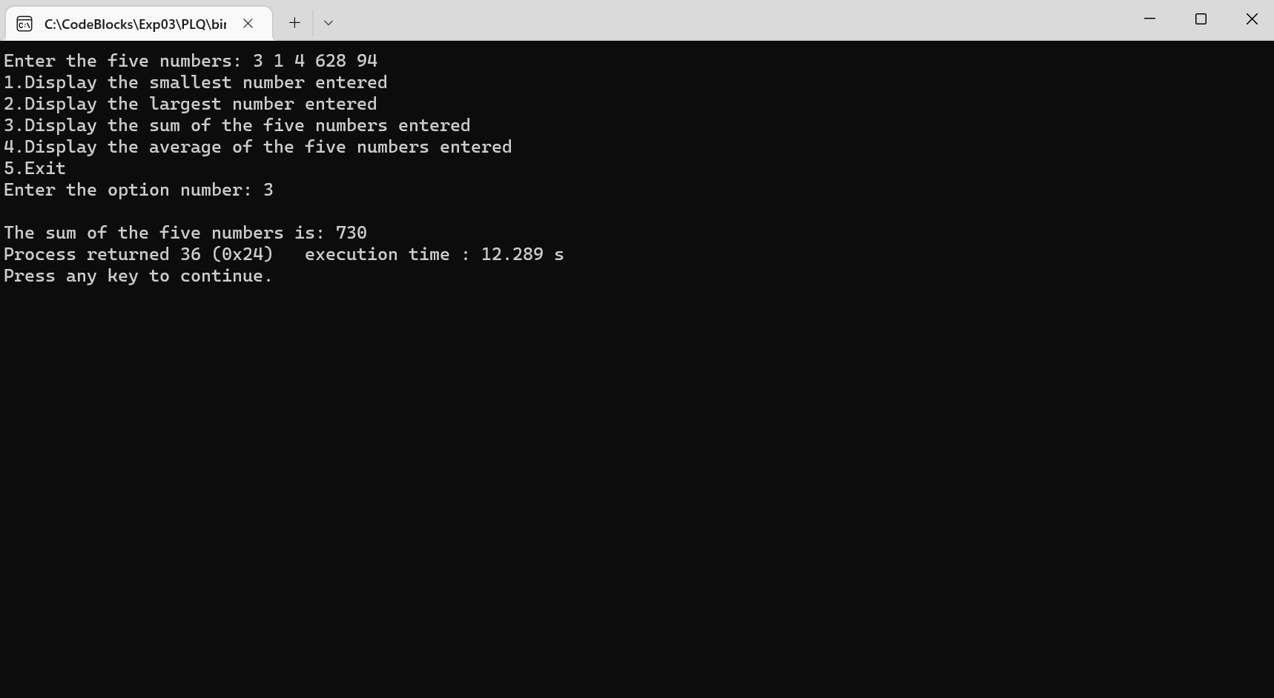

For option (4):

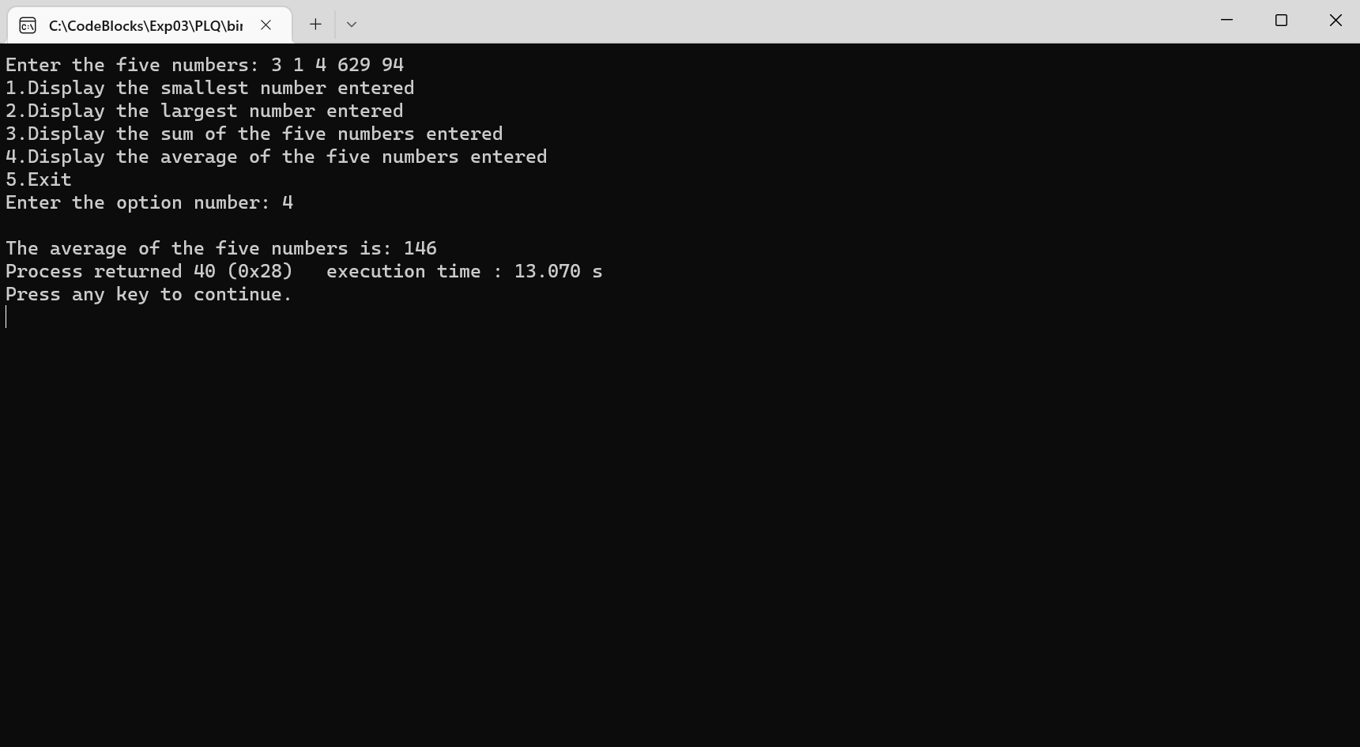

For option (5):

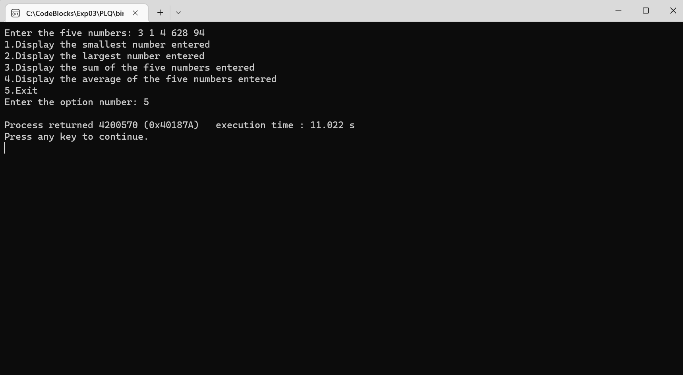

For any option other than 1-5:

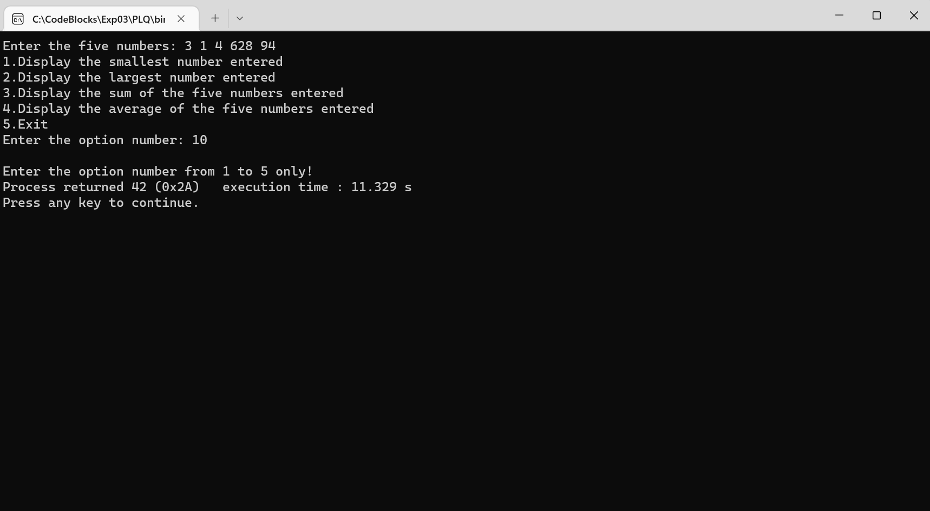

**Date: _____________ Signature of faculty in-charge**

**Department of Science and Humanities**

Page No PIC Sem I/August-December 2022-23